***UOM Display issue in Assigned and Unussigned Screen***

**Scenario:** System shows **Each** as **Pallet** in the UOM display, both Assigned and Un-assigned Screen. We can use **Case/Each** instead of **Pallet**.

**Step1:**

Below is the screen shot from Demand allocation. The NSN **895001E621981** allocates 18 CS and 5 Each.



**Step2:**

The below screen shot from Assigned Screen. In this below one line shows Pallet.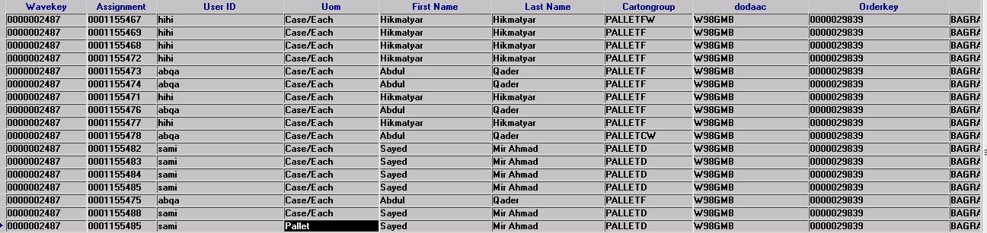

**Step3:**

When we open **show picks** in that particular line assignment number **0001155485,** there is no pallets to pick. We have only CS and EA. The below is the screen shot for our reference. This problem appears whenever **EA** comes.

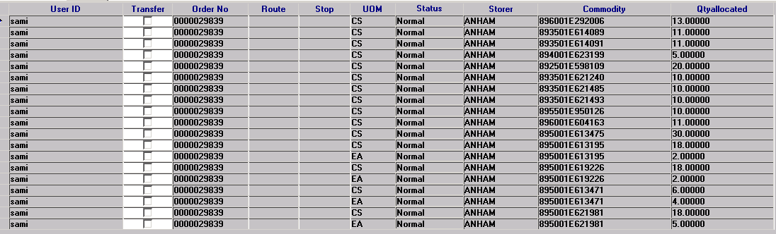

**Conclusion:**

Whenever **EA** appears on the screen, the **UOM in Assigned and unassigned** screen displays as **Pallet**.